Kurtosis : Measure of tailedness of a distribution

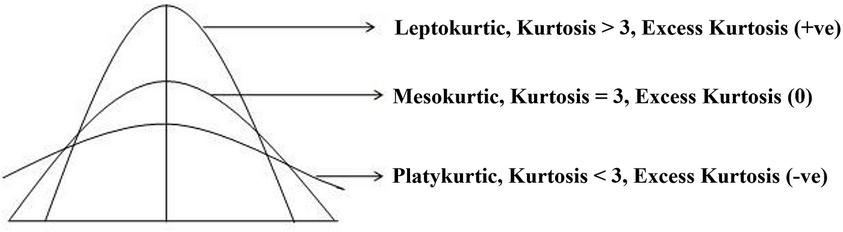

The kurtosis values of all the exam scores are less than 3 which implies that this dataset has Platykurtic curve which means that the scores are flatter than normal and has fewer extreme values.The students scored around the same , spread out evenly and no big spikes of high or low scores.

Skewness : Measure of Asymmetry of a distribution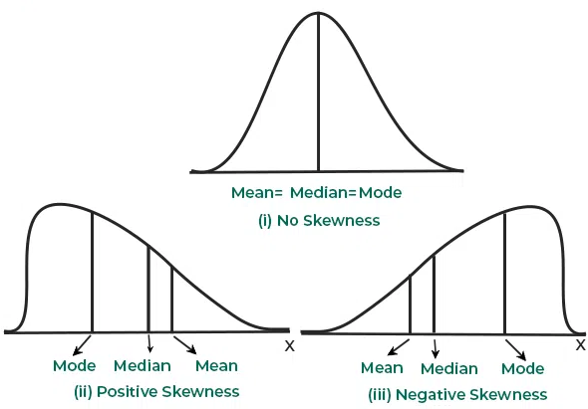
Mean > Median > Mode Mean < Median < Mode

Interpretation of the skew values:
0 - Perfectly symmetric
-0.5 to +0.5 - Approximately symmetric
+0.5 to +1 - Moderately right skewed
>+1 - Highly right skewed
-0.5 to -1 - Moderately left skewed
<-1 - Highly left skewed

Referring to the table , its evident that hsc , degree , etest scores are approximately symmetric which implies that students scored around the same range.However salary data is negative skewed and ssc scores are positive skewed.

